ShopEZ – E-Commerce Application

1. Project Title
ShopEZ – E-Commerce Application

2. Introduction
ShopEZ is a modern e-commerce web application designed to provide users with a seamless online shopping experience. The platform enables customers to browse products, view detailed product information, manage shopping carts, and place orders efficiently. The application focuses on simplicity, responsiveness, and ease of use.

3. Project Objective
The objective of ShopEZ is to develop a user-friendly online shopping platform that allows:
- Product browsing and searching
- Cart management
- Secure order placement
- User account management
- Efficient product management

4. Technologies Used

Frontend
- HTML5
- CSS3
- JavaScript
- TypeScript
- Vite

Backend
- Node.js
- Express.js

Database
- MongoDB

Version Control & Deployment
- GitHub
- Vercel

5. System Requirements

Software Requirements
- Windows 10/11, Linux, or macOS
- Node.js v16+
- npm v8+
- Visual Studio Code
- Git & GitHub
- MongoDB
- Google Chrome or Firefox

Hardware Requirements
- Intel Core i5 / Ryzen 5 Processor
- Minimum 8GB RAM
- 1GB Free Storage
- Internet Connection

6. Project Architecture

Frontend Layer
The frontend provides the user interface for:
- Home Page
- Product Listings
- Product Details
- Cart Management
- User Authentication

Backend Layer
The backend handles:
- API Requests
- Product Management
- User Management
- Order Processing
- Database Operations

Database Layer
MongoDB stores:
- User Information
- Product Details
- Cart Data
- Orders

7. Features

User Features
- Browse products
- View product details
- Add products to cart
- Place orders
- Manage profile

Admin Features
- Add products
- View products
- Manage orders
- Monitor platform activity

Additional Features
- Responsive design
- Fast page loading
- Secure data handling
- Easy navigation

8. Database Design

User Collection
Stores:
- User Name
- Email
- Password

Product Collection
Stores:
- Product Name
- Description
- Price
- Category
- Product Image

Cart Collection
Stores:
- User ID
- Product ID
- Quantity

Orders Collection
Stores:
- User ID
- Product Information
- Order Date
- Order Status

9. Project Workflow
- User visits the website.
- User browses available products.
- User selects a product.
- Product is added to cart.
- User proceeds to checkout.
- Order is placed successfully.
- Order details are stored in the database.

10. Repository Details
GitHub Repository:
https://github.com/kalletivansh/shopez1
Live Deployment:
https://shopez1.vercel.app

11. Installation Steps

Clone Repository
git clone https://github.com/kalletivansh/shopez1.git

Install Dependencies
npm install

Run Application
npm run dev

Build Application
npm run build

12. Testing
The application was tested for:
- Page Navigation
- Product Display
- Cart Operations
- Order Placement
- Responsive Design
- Deployment Verification

13. Conclusion
ShopEZ successfully demonstrates the implementation of a modern e-commerce application using web technologies. The project provides a scalable architecture, responsive interface, and efficient shopping workflow. It showcases frontend development, backend integration, datab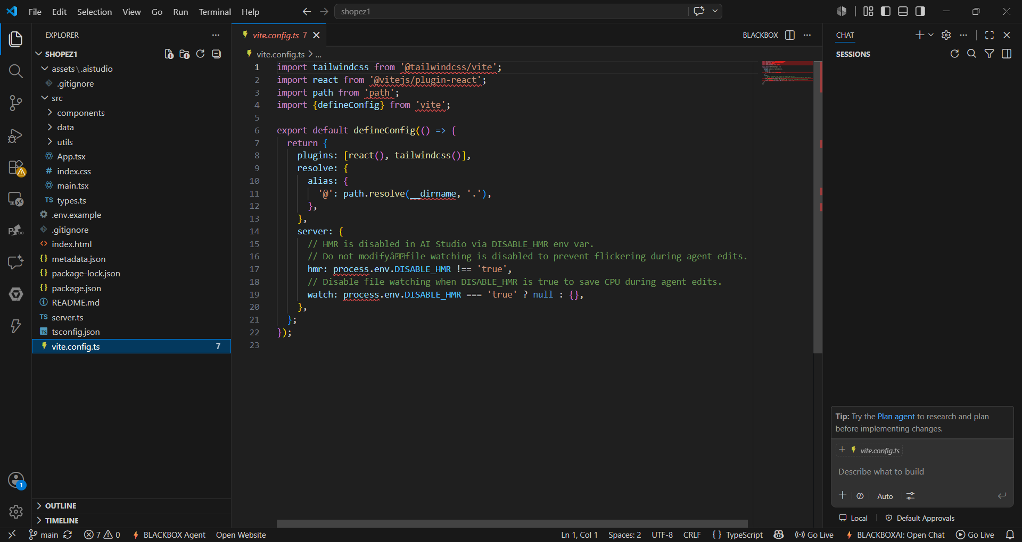ase management, deployment, and version control practices.
